**WEEK 6 HANDS-ON**

Q1)

CODES

1. App.js

import './App.css';

function App() {

return (

<div className="App">

<h1>welcome to the first session of React</h1>

</div>

);

}

export default App;

Outputs)

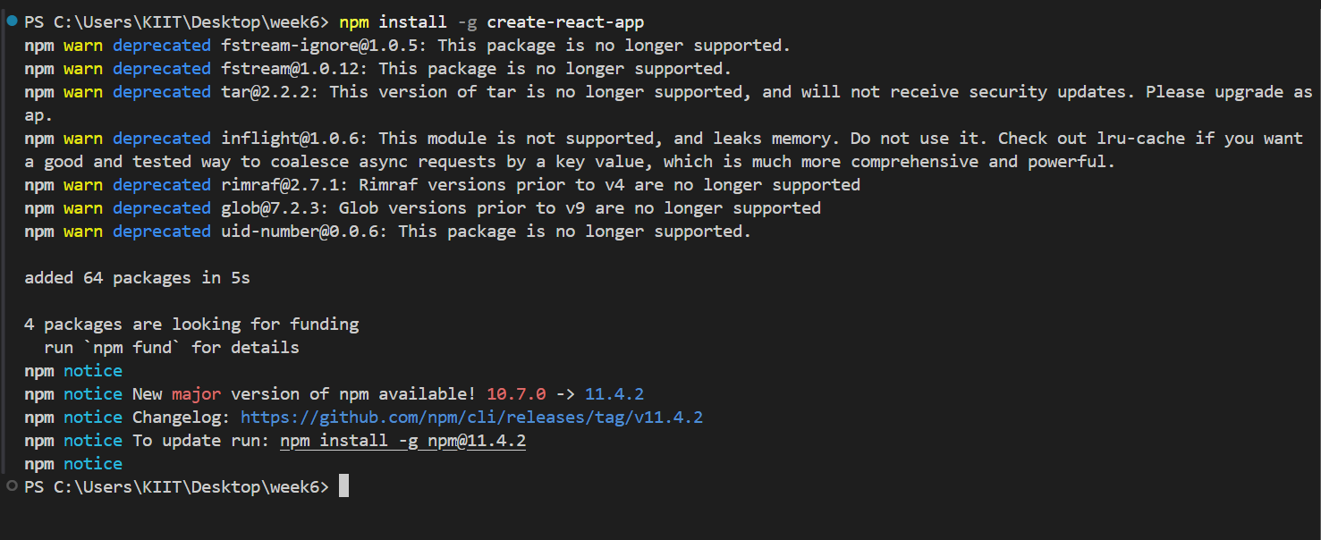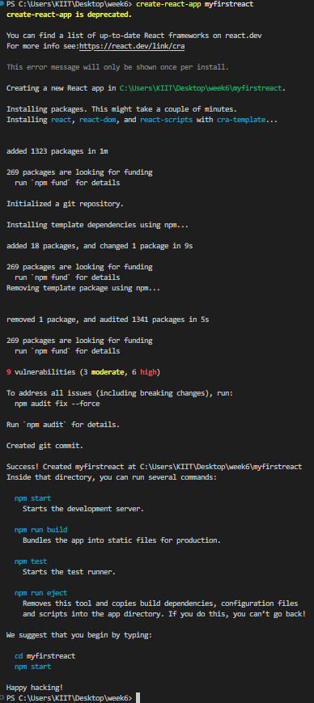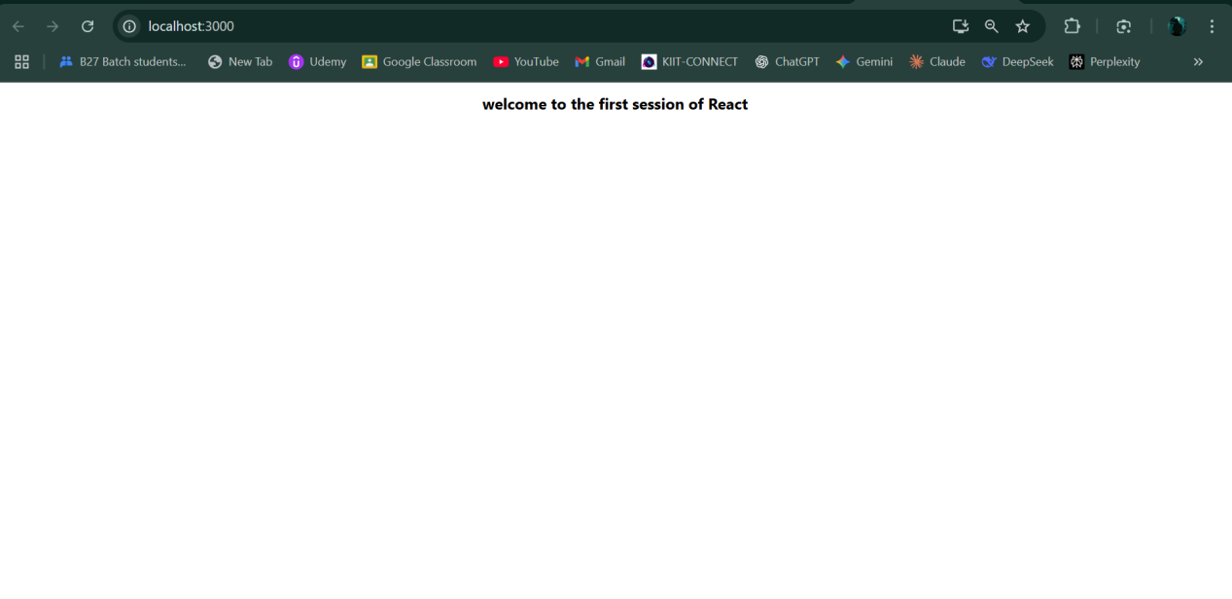

Q2)

CODES

1. Home.js

import React from 'react';

function Home (){

return <h1>Welcome to the Home page of Student Management Portal</h1>;

}

export default Home;

1. About.js

import React from 'react';

function About (){

return <h1>Welcome to the About page of the Student Management Portal</h1>;

}

export default About;

1. Contact.js

import React from 'react';

function Contact (){

return <h1>Welcome to the Contact page of the Student Management Portal</h1>;

}

export default Contact;

1. App.js

import Home from './Components/Home';

import About from './Components/About';

import Contact from './Components/Contact';

function App() {

return (

<div>

<Home />

<About />

<Contact />

</div>

);

}

export default App;

OUTPUTS)

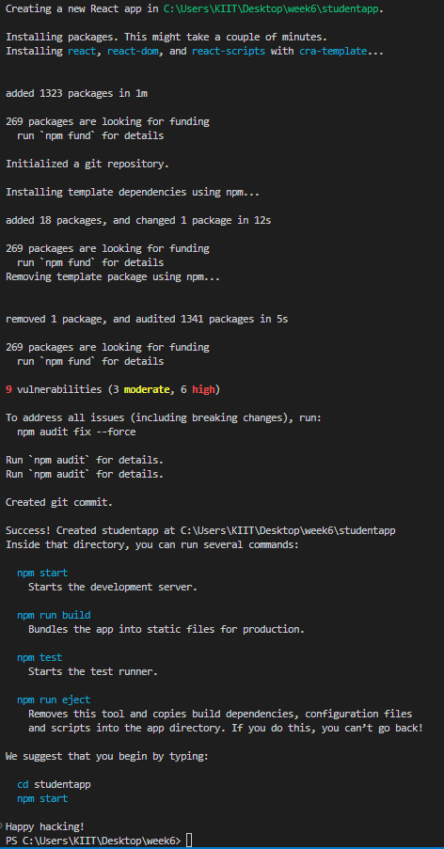

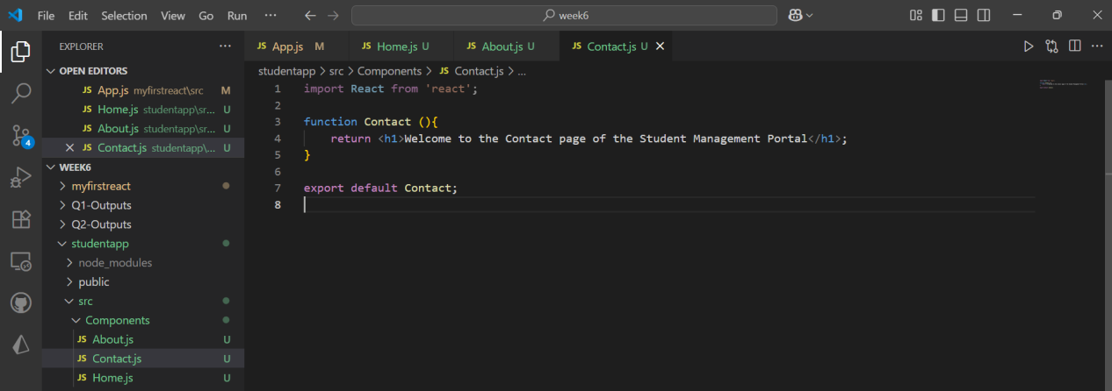

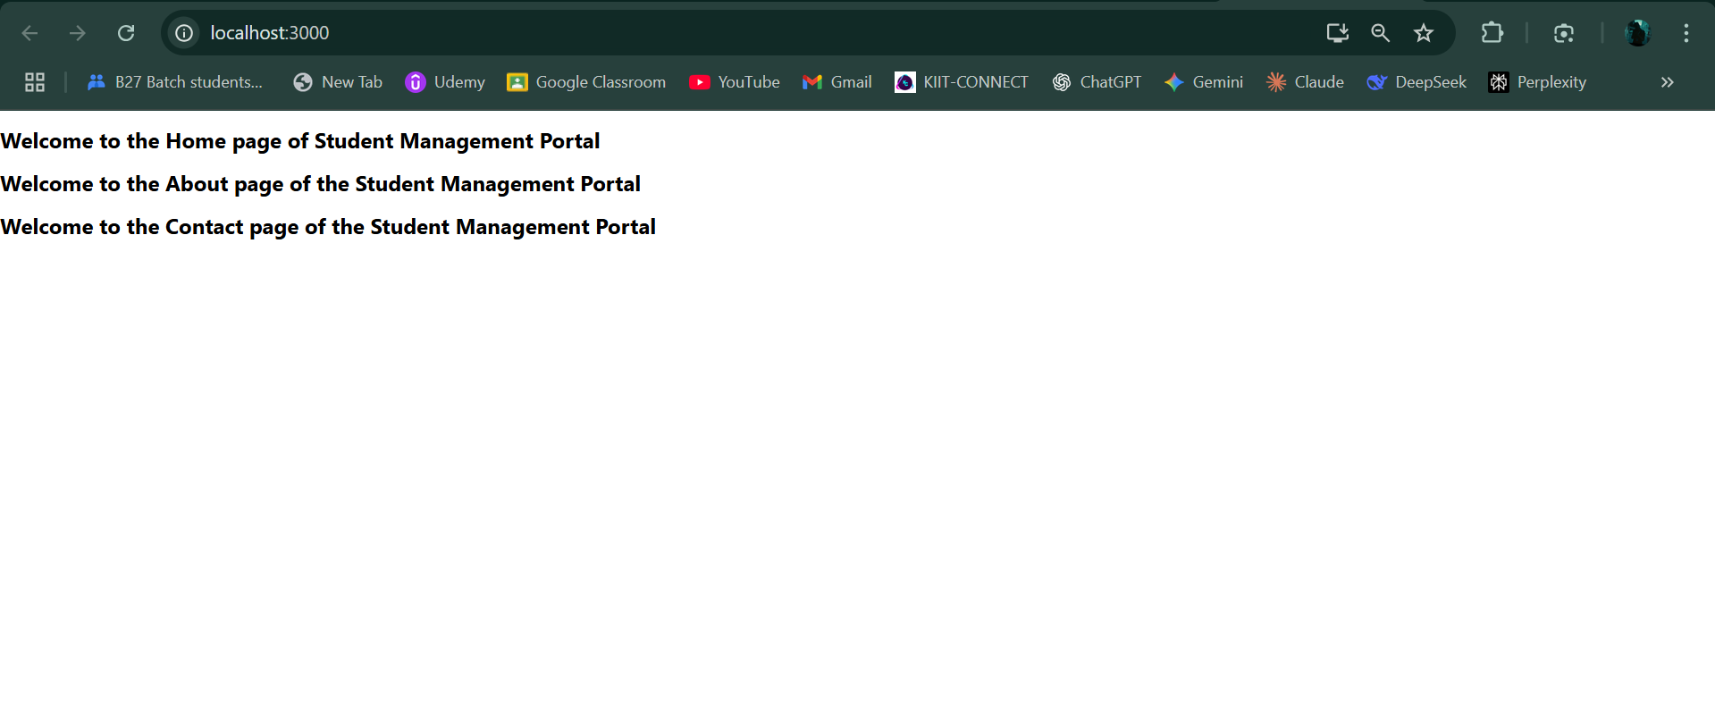

Q3) CODES)

1. CalculateScore.js

const CalculateScore = ({ name, school, total, goal }) => {

let percentage = (total / 500) * 100;

return (

<div className="student-info">

<div className="header">

<h1>Student Details</h1>

</div>

<p><strong>Name:</strong> {name}</p>

<p><strong>School:</strong> {school}</p>

<p><strong>Total:</strong> {total}</p>

<p><strong>Percentage:</strong> {percentage}%</p>

<p><strong>Goal:</strong> {goal}</p>

</div>

);

};

export default CalculateScore;

1. mystyle.css

.student-info {

border: 2px solid #4CAF50;

border-radius: 10px;

padding: 20px;

margin: 20px;

width: 300px;

box-shadow: 0 4px 8px 0 rgba(0,0,0,0.2);

font-family: Arial, sans-serif;

}

.header {

background-color: #4CAF50;

color: white;

padding: 10px;

border-radius: 8px 8px 0 0;

margin: -20px -20px 10px -20px;

text-align: center;

}

1. App.js

import './App.css';

import CalculateScore from './Components/CalculateScore';

import './Stylesheets/mystyle.css';

function App() {

return (

<div className="App">

<CalculateScore name="Rick" school="St. Anns" total={459} goal="Become a Full-Stack Developer"/>

</div>

);

}

export default App;

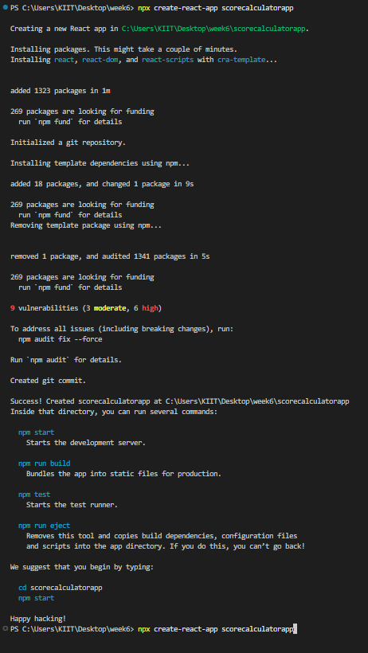

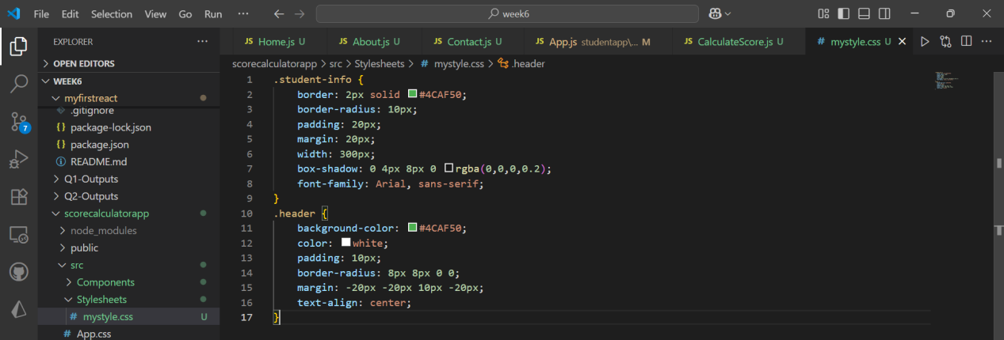

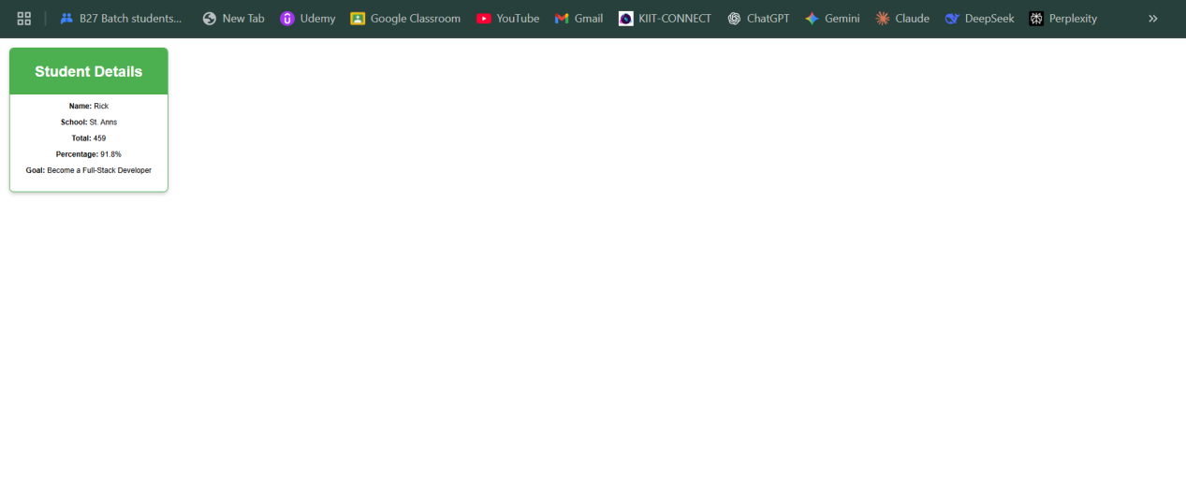

Q4)

Codes)

1. App.js

import './App.css';

import Posts from './Posts';

function App() {

return (

<div className="App">

<Posts />

</div>

);

}

export default App;

1. Posts.js

import React from 'react';

class Posts extends React.Component {

// Initialize the component state in the constructor [cite: 51]

constructor(props){

super(props);

this.state = {

posts: [],

error: null

};

}

// Method to fetch data from the API [cite: 52]

loadPosts() {

fetch('https://jsonplaceholder.typicode.com/posts') // [cite: 53]

.then(response => response.json())

.then(data => {

this.setState({ posts: data });

})

.catch(error => {

this.setState({ error: error.message });

});

}

// Call loadPosts() after the component mounts [cite: 55]

componentDidMount() {

this.loadPosts();

}

// Handle any errors that occur in child components [cite: 59]

componentDidCatch(error, info) {

this.setState({ error: error.message });

alert("An error occurred: " + error.message);

}

// Render the list of posts [cite: 57]

render() {

const { posts, error } = this.state;

if (error) {

return <div>Error: {error}</div>;

}

return (

<div>

<h1>Blog Posts</h1>

{posts.map(post => (

<div key={post.id} style={{ borderBottom: '1px solid #ccc', marginBottom: '20px', paddingBottom: '10px' }}>

<h2>{post.title}</h2>

<p>{post.body}</p>

</div>

))}

</div>

);

}

}

export default Posts;

1. Post.js

class Post {

constructor(id, title, body){

this.id=id;

this.title=title;

this.body=body;

}

}

export default Post;

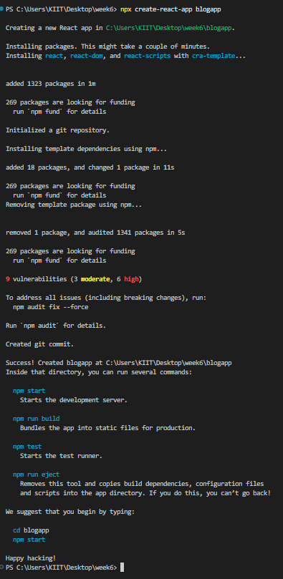

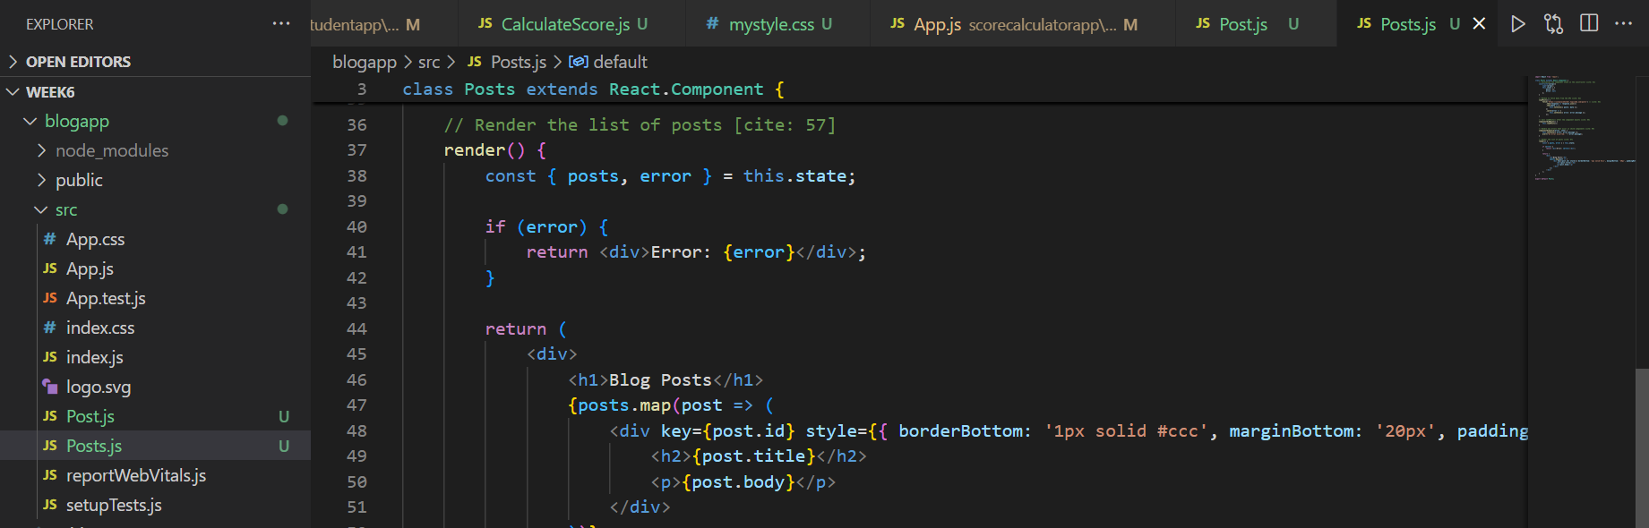

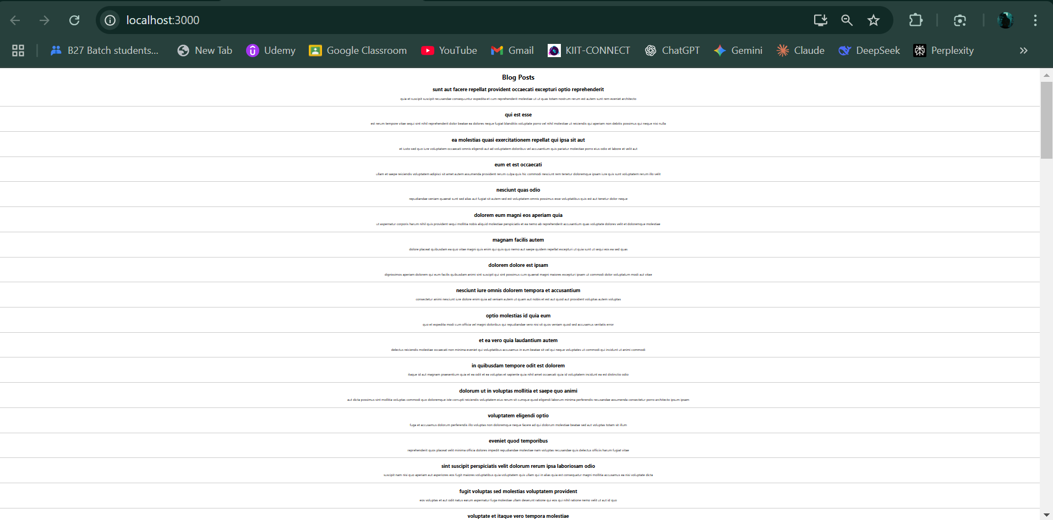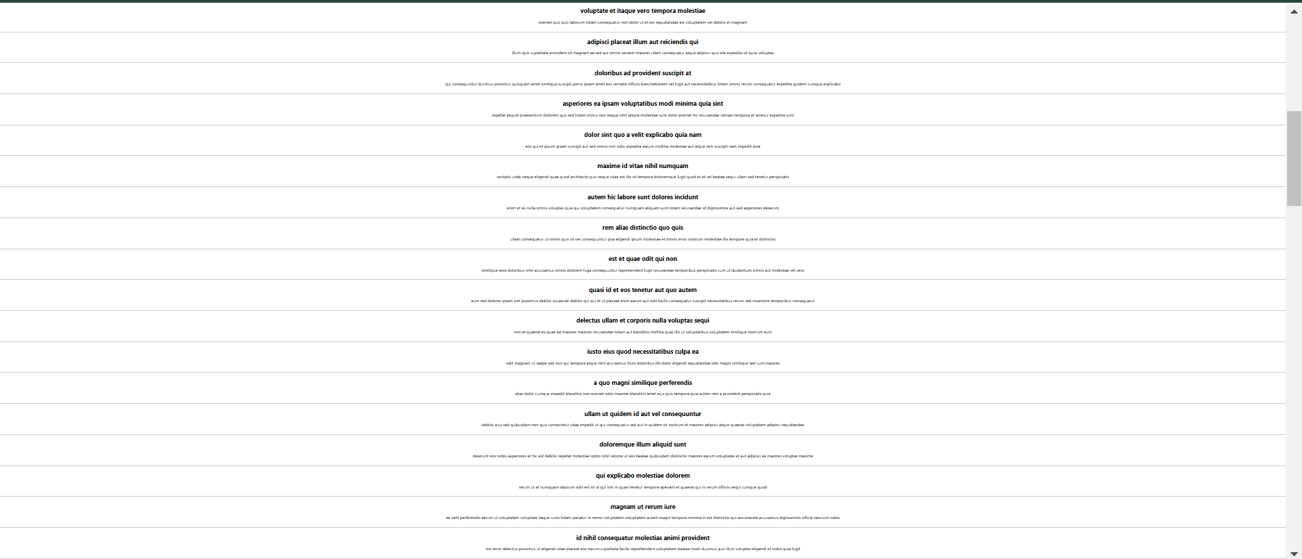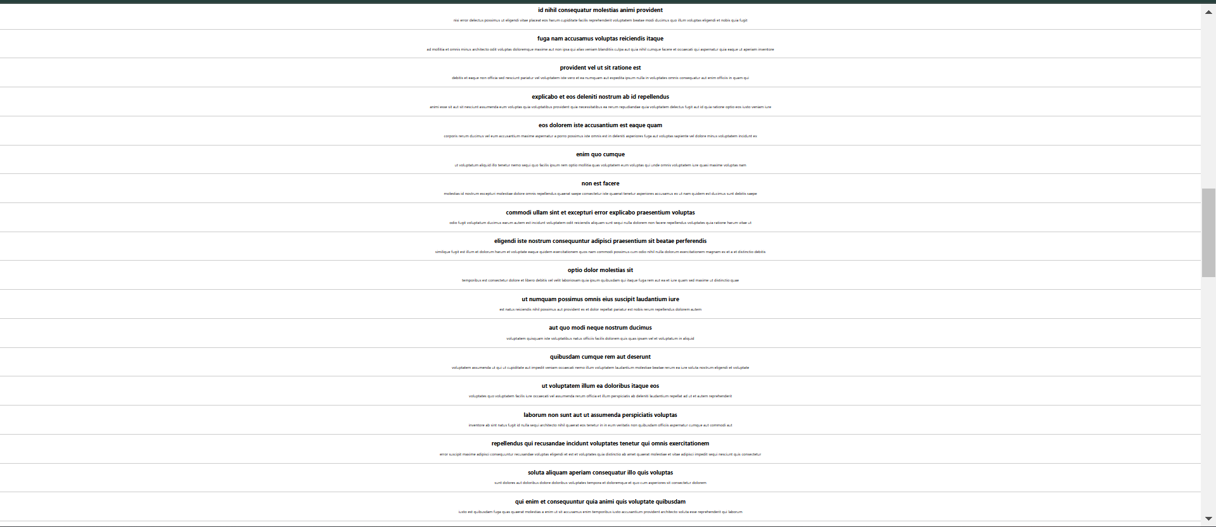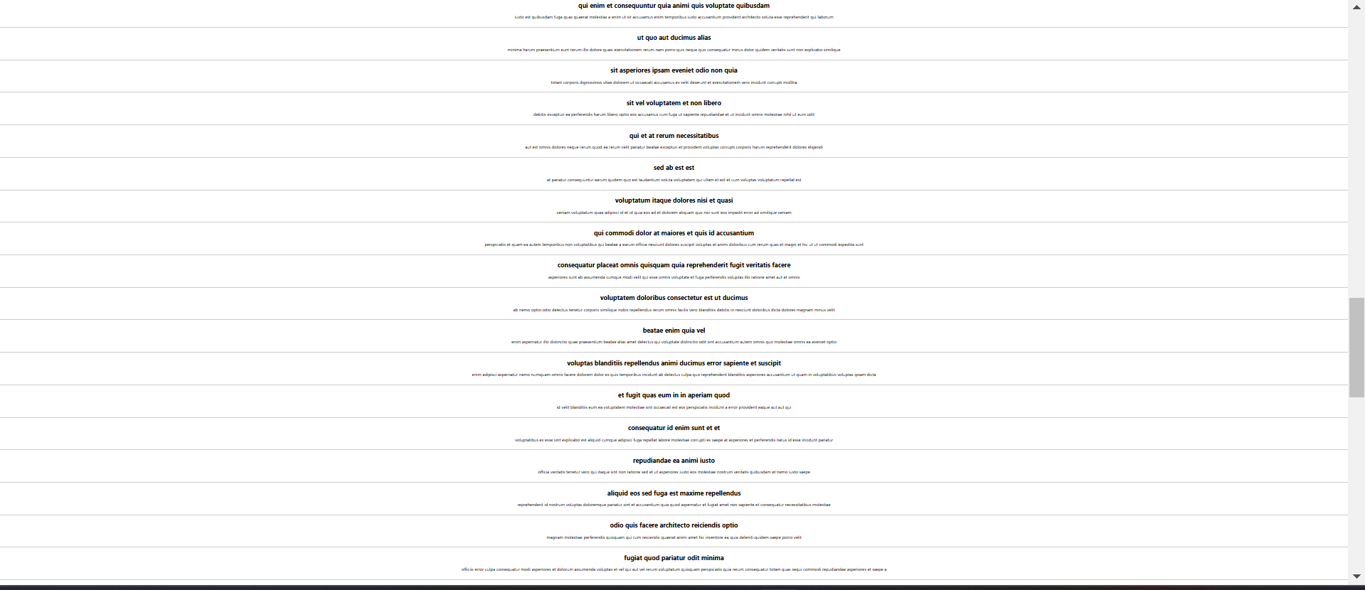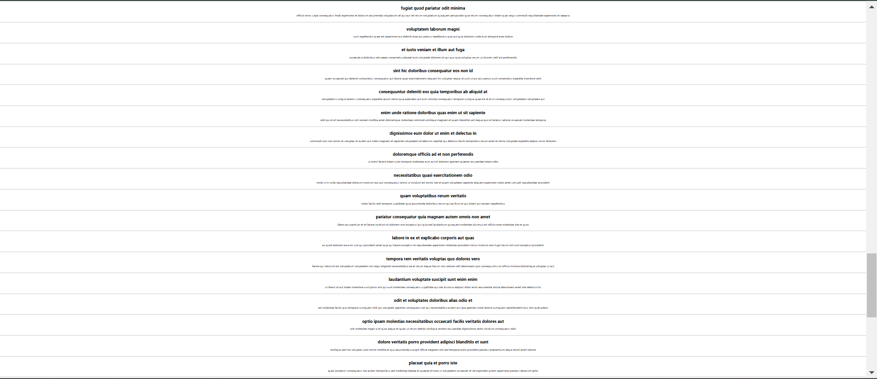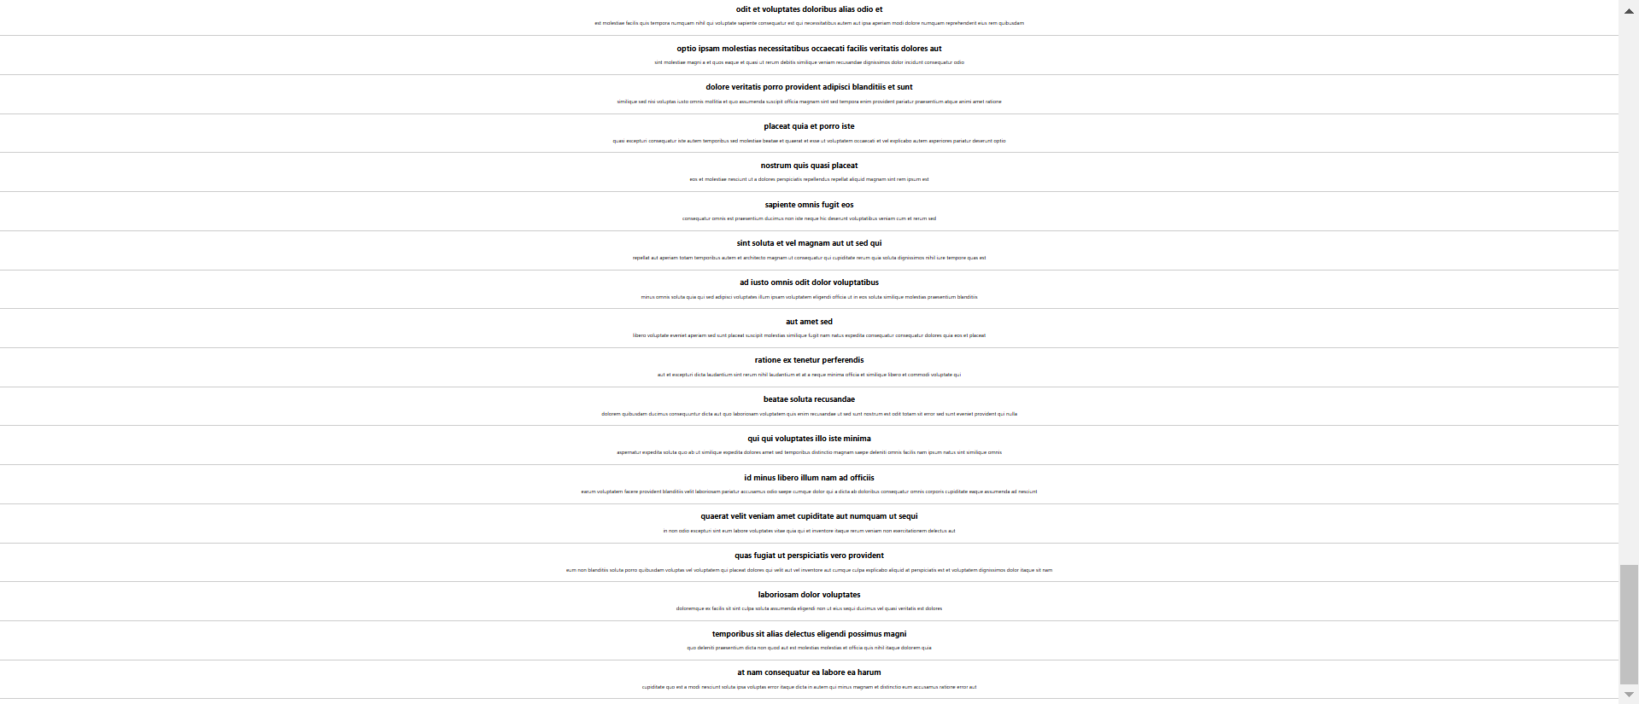

Q5)

CODES

1. CohortDetails.module.css

/* Defines the box class with the specified properties */

.box {

width: 300px; /* [cite: 58] */

display: inline-block; /* [cite: 59] */

margin: 10px; /* [cite: 60] */

padding: 10px 20px; /* [cite: 61, 62] */

border: 1px solid black; /* [cite: 63] */

border-radius: 10px; /* [cite: 64] */

text-align: left;

}

/* Sets the font weight for all <dt> elements */

dt {

font-weight: 500; /* [cite: 65] */

}

2)CohortDetails.js

import React from 'react';

import styles from './CohortDetails.module.css'; // Import the CSS module

// This component receives cohort data as a prop

const CohortDetails = ({ cohort }) => {

// Define inline style for h3 based on cohort status

// Green for "Ongoing", Blue for everything else [cite: 68]

const headerStyle = {

color: cohort.status === 'Ongoing' ? 'green' : 'blue'

};

return (

// Apply the 'box' class from the CSS module [cite: 67]

<div className={styles.box}>

<h3 style={headerStyle}>{cohort.name}</h3>

<dl>

<dt>Started On</dt>

<dd>{cohort.startedOn}</dd>

<dt>Current Status</dt>

<dd>{cohort.status}</dd>

<dt>Coach</dt>

<dd>{cohort.coach}</dd>

<dt>Trainer</dt>

<dd>{cohort.trainer}</dd>

</dl>

</div>

);

};

export default CohortDetails;

Output)

